Agentic Knowledge
Management Platform
Pilot Proposal
Microsoft Copilot Studio · MCP · Azure-native

Scope: Pilot Engagement · 8 Weeks
Approach: Agent-First · Modular · Governance-by-Design
Authored by: Nisarg
Prepared for: the Client — Technology Leadership

Table of Contents
1. Executive Summary 3
2. Requirement Alignment 3
3. Solution Overview 4
3.1 Why an agent-first architecture 4
3.2 The role of MCP 5
4. Agent Design 5
4.1 Orchestrator Agent 5
4.2 Domain Specialist Agents 5
4.3 Why Confluence and SharePoint for the pilot 6
5. Reference Architecture and Technology Stack 6
5.1 The three net-new components 7
5.2 What is leveraged from the existing estate 7
6. Access Control and Security 8
6.1 Path A — Microsoft Graph native inheritance 8
6.2 Path B — Security Trimming on Azure AI Search 8
6.3 Why access control is enforced inside the index 9
6.4 Handling highly confidential data 9
7. Data Flow, Recency, and Accuracy 9
7.1 Graph-connected sources — recency is automatic 9
7.2 Index-backed sources — two-mode refresh 9
7.3 Accuracy signals surfaced to users 9
8. Pilot Scope — 8 Weeks 10
8.1 In-scope for pilot 10
8.2 Out of scope for pilot (Phase 2+) 10
8.3 Eight-week plan 10
9. Governance, Monitoring and Audit 11
10. Pilot Success Metrics 12
11. Team and Commercial Shape 12
12. Risks and Mitigations 13
13. Phase 2 Expansion 13
14. Next Action 14
15. Phase 2 Scope — 10 Weeks 15
8.1 In-scope for phase 2 15
8.2 Ten-week plan 15
16. Governance, Monitoring and Audit 16
17. Phase 2 Success Metrics 16
18. Team and Commercial Shape 17
19. Risks and Mitigations 18
20. Next Actions 18

1. Executive Summary
This proposal describes an eight-week pilot to deliver an agent-first Knowledge Management platform on the Client's existing Microsoft 365 and Azure estate. The architecture uses Microsoft Copilot Studio to host a small set of specialist agents — one per source system — coordinated by an orchestrator agent. Each agent connects to its source in real time through MCP (Model Context Protocol), the emerging open standard for modular AI connectors. Access control is enforced at the source or index level so that users only ever see content they are already permitted to see.
The pilot is deliberately scoped. It exercises the full architecture end-to-end on two of the five target sources — Confluence and SharePoint — with 50 to 100 pilot users. Once the foundation is validated in production use, the remaining sources (Jira, ServiceNow, internal documentation) are onboarded through the same MCP pattern with minimal incremental engineering.
Why this approach wins the Client's requirements
Real-time grounding via MCP tools calling live source APIs, not stale indexes.
Native access control — Microsoft Graph inherits SharePoint and OneDrive permissions automatically; Security Trimming enforces permissions inside Azure AI Search for non-Graph sources.
Minimal operational overhead — nine of twelve architecture layers reuse the Client's existing Microsoft investment.
Modular onboarding — MCP is the standardized connector protocol; each new source is a new MCP server, not a bespoke integration.
Unified governance — Microsoft Purview, Entra ID logs, and Copilot Analytics provide a single auditable view of usage, access patterns, and compliance.

2. Requirement Alignment
This proposal has been revised in direct response to the technical requirements shared by the Client. Each requirement is addressed by a specific architectural decision.
Client requirement | Architectural response | Section
Knowledge agent with real-time grounding + citations | Declarative agents in Copilot Studio invoke MCP tools that query source systems live; citations are native to Copilot responses | §4, §5
Enforce access controls per user per dataset | Graph connectors (SharePoint, OneDrive) inherit source ACLs natively; Security Trimming on Azure AI Search for Jira / ServiceNow / Confluence with 15-minute sync | §6
Handle confidential data across varying access levels | Access enforced at source or index — forbidden content never returned. Immutable audit captures every retrieval decision | §6, §9
Minimize operational overhead · leverage existing tools | Copilot Studio (existing), Entra ID (existing), Purview (existing), Azure tenant (existing). New components limited to MCP servers and evaluation harness | §5, §8
Dynamic indexing, metadata, and access control | Graph connectors auto-propagate; Azure AI Search indexer handles metadata; scheduled ACL sync every 15 minutes plus event-driven on permission change | §6, §7
Scalable architecture with modular connectors | MCP (Model Context Protocol) is the standardized connector layer — one MCP server per source, onboardable independently | §4, §5
Centralized monitoring and auditing | Microsoft Purview (data lineage) + Entra ID logs (access) + Copilot Analytics (usage) + Azure Monitor (infrastructure) — unified dashboard | §9

3. Solution Overview
The platform is organized around five specialist agents and one orchestrator, all hosted in Microsoft Copilot Studio. Users interact through the Microsoft 365 Copilot surfaces they already use (Teams, Outlook, Word) or through a lightweight custom web UI for power users. The orchestrator classifies intent, routes to the appropriate domain agent, and assembles the final response with citations.
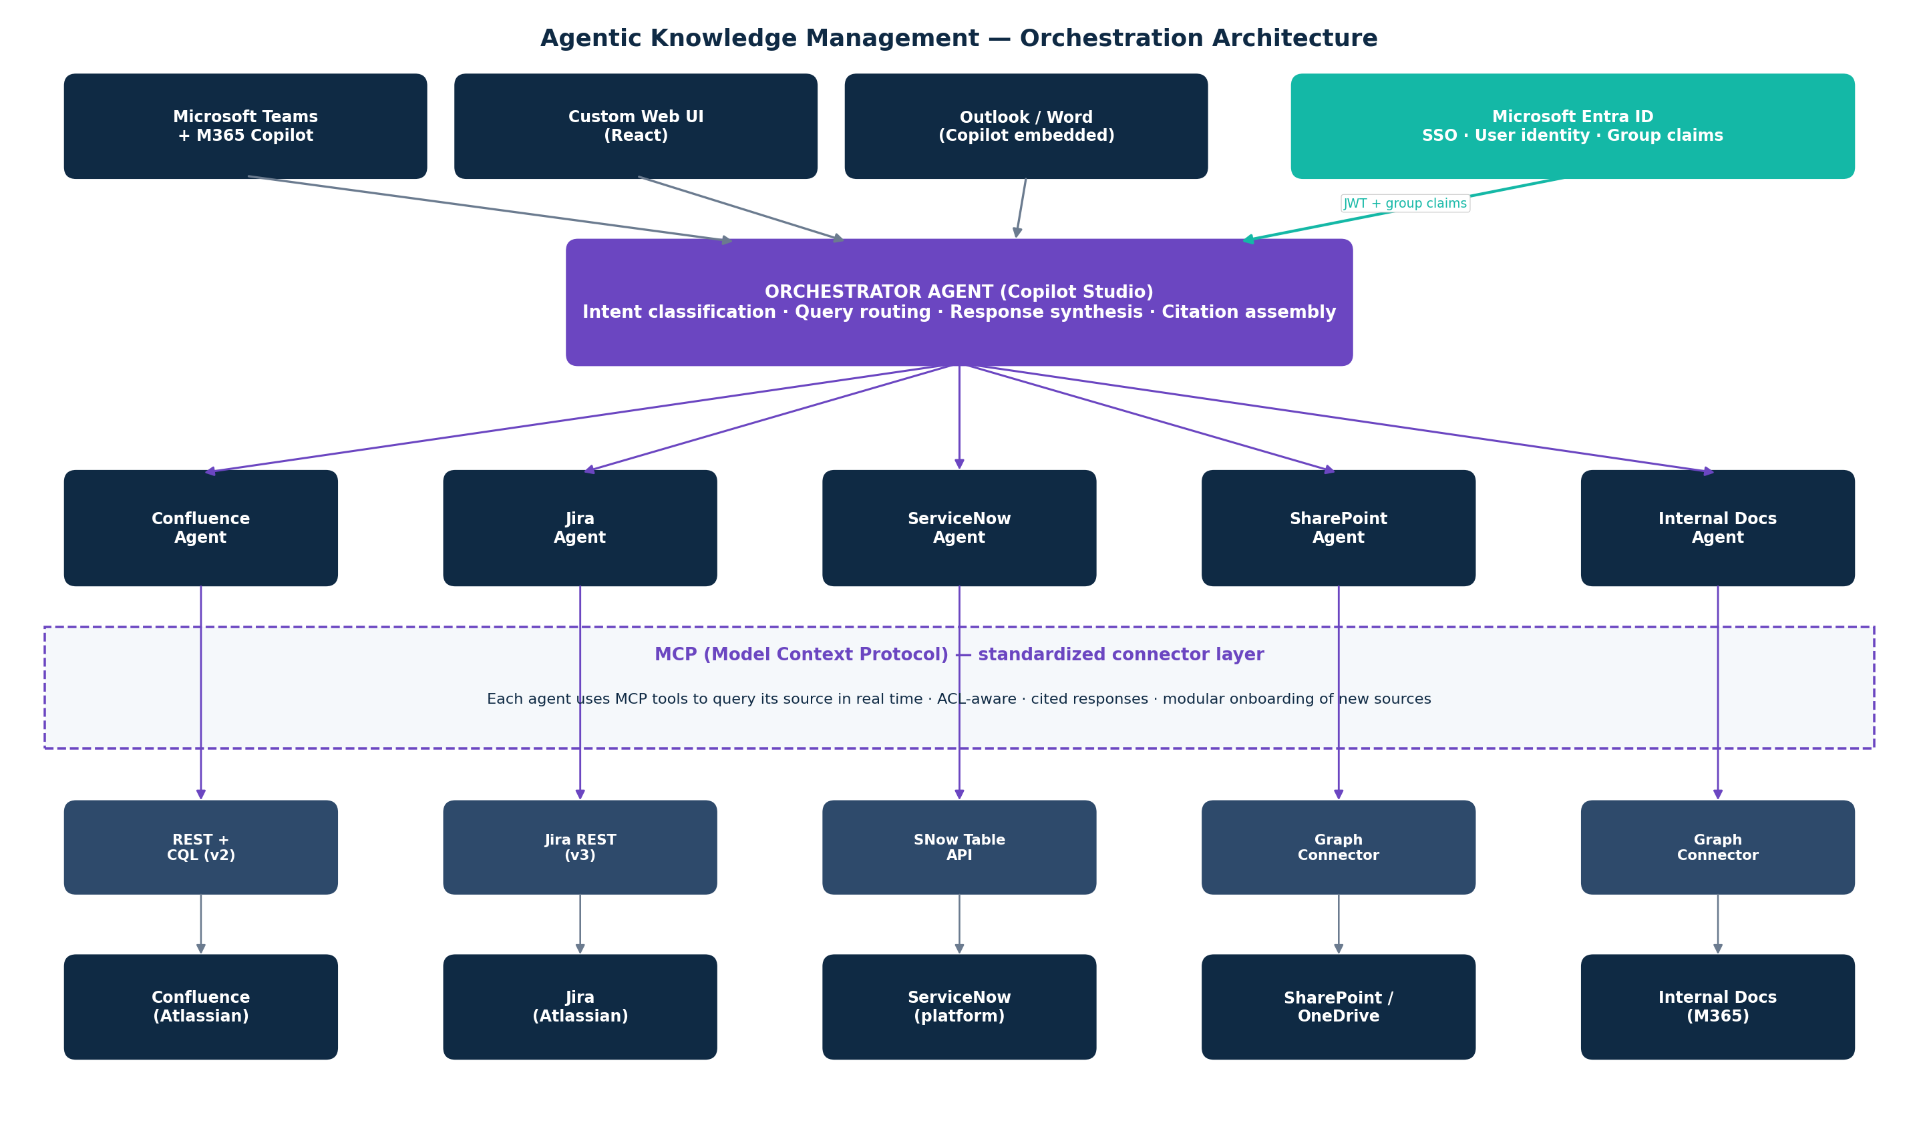
Figure 1 — Agentic orchestration architecture: the orchestrator agent routes queries to specialist domain agents; each agent uses MCP tools to query its source in real time.

3.1 Why an agent-first architecture
A single monolithic retrieval system over five heterogeneous sources accumulates compromises. Each source has its own schema, its own access model, its own update cadence, and its own quirks. Flattening them into one unified index loses nuance at ingestion and then tries to recover it at retrieval. Agent-first inverts this: each source is treated as a first-class citizen with a specialist agent that understands its shape, its ACL model, and its retrieval patterns. The orchestrator handles cross-source reasoning when needed.
This pattern is native to Microsoft Copilot Studio, which supports declarative agents, agent actions, and multi-agent orchestration as first-class primitives. The Client's existing Copilot Studio license is therefore leveraged directly — not worked around.

3.2 The role of MCP
MCP (Model Context Protocol) is the open standard that allows agents to invoke external tools and data sources in a consistent, type-safe way. For this architecture, MCP solves three problems simultaneously:
- Standardization — every source connector implements the same protocol shape, making onboarding new sources a matter of writing one MCP server.
- Real-time access — MCP tools query live source APIs at agent runtime; retrieval is grounded in current data, not a stale index.
- Security context propagation — MCP tool calls carry the user's identity context, enabling native ACL inheritance through Microsoft Graph and identity-aware calls to non-Graph sources.

4. Agent Design
Six agents are designed in total — one orchestrator and five domain specialists. In the pilot phase, only the orchestrator and two specialist agents (Confluence and SharePoint) are deployed. The remaining three are templated and ready for the post-pilot rollout.

4.1 Orchestrator Agent
- Purpose — receives every user query, classifies intent, selects one or more domain agents to invoke, and synthesizes the final cited response.
- Hosted in — Microsoft Copilot Studio as a declarative agent with structured routing logic.
- Key actions — intent classification (rule-based with LLM fallback); ACL pre-check (verify user has at least one accessible source); response synthesis with strict-citation prompting; groundedness check before response.
- Fallback behavior — if no domain agent returns confident results, the orchestrator returns a structured 'I cannot answer this confidently from available knowledge' response with the best partial evidence. No hallucination to fill silence.

4.2 Domain Specialist Agents
Agent | Source | MCP tool type | ACL model | Pilot?
Confluence Agent | Atlassian Confluence | Custom MCP server (REST v2 + CQL) | Security Trimming on Azure AI Search (ACLs sync'd) | ✓ Pilot
SharePoint Agent | SharePoint / OneDrive | Microsoft Graph Connector | Native Graph ACL inheritance — runs as user | ✓ Pilot
Jira Agent | Atlassian Jira | Custom MCP server (REST v3) | Security Trimming on Azure AI Search | Phase 2
ServiceNow Agent | ServiceNow platform | Custom MCP server (Table API) | Security Trimming with role-based filter | Phase 2
Internal Docs Agent | M365 internal docs | Microsoft Graph Connector | Native Graph ACL inheritance | Phase 2

4.3 Why Confluence and SharePoint for the pilot
- Together they cover both access-control paths — Security Trimming (Confluence) and native Graph ACL (SharePoint) — validating the full security architecture in the pilot itself.
- They represent the highest-volume knowledge surface at most enterprises — the pilot's measurable impact is therefore meaningful.
- SharePoint via Graph connectors is the cleanest integration path — near-zero custom code — which de-risks the technical pilot.
- Confluence via custom MCP server proves the MCP server pattern that will be reused for Jira and ServiceNow in Phase 2.

5. Reference Architecture and Technology Stack
The stack below is organized by layer. Nine of twelve layers reuse the Client's existing Microsoft investment. Net-new components are limited to MCP servers, Content Safety integration, and the evaluation harness — all lightweight in a pilot context.
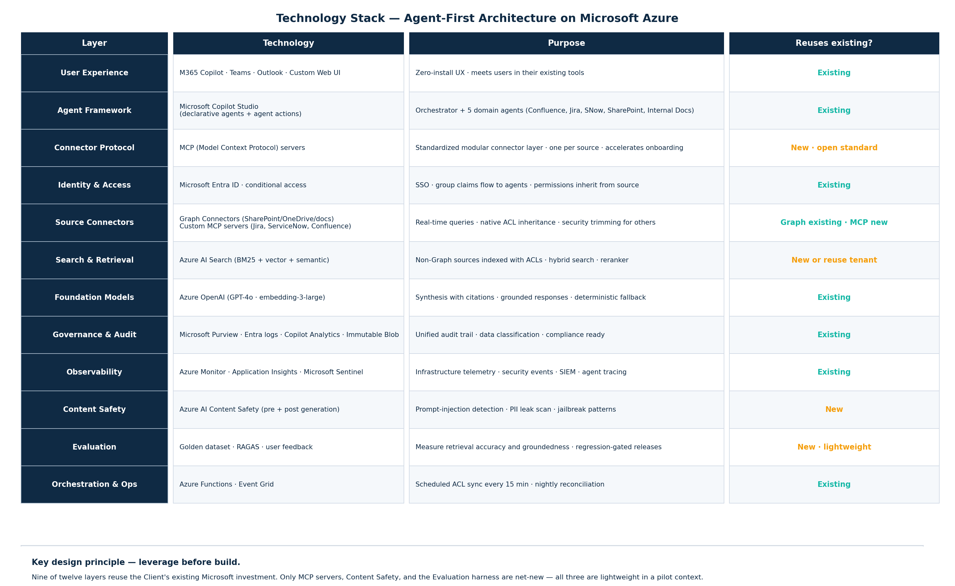
Figure 2 — Technology stack showing layer-by-layer composition. The 'Reuses existing?' column identifies components already present in the Client's environment.

5.1 The three net-new components
- MCP servers — containerized services implementing the Model Context Protocol for each non-Graph source. Each server is small (typically under 500 lines of code), stateless, and independently deployable on Azure Container Apps.
- Content Safety integration — Azure AI Content Safety called pre- and post-generation for prompt-injection detection, PII leak scanning, and jailbreak pattern recognition. A line of configuration per agent.
- Evaluation harness — a lightweight pilot-scale system: golden dataset of 50 curated questions, RAGAS scoring weekly, user thumbs and correction capture flowing into SME-triaged regression tests.

5.2 What is leveraged from the existing estate
- Microsoft Copilot Studio — agent authoring, orchestration, and Copilot surface integration.
- Microsoft Entra ID — identity, SSO, group claims propagation, conditional access.
- Microsoft Graph — SharePoint and OneDrive connectors with native ACL inheritance.
- Azure OpenAI — foundation models already provisioned in the Client's tenant.
- Microsoft Purview — data classification, lineage, and governance catalog.
- Azure Monitor + Sentinel — infrastructure telemetry and security event management.
- Azure AI Search — if already provisioned, reused; otherwise deployed as a single shared index.

6. Access Control and Security
Access control is the Client's principal concern and the defining design constraint of this architecture. The solution uses two complementary paths to ensure that users see only content they are already permitted to see — without requiring the Client to maintain a parallel permissions layer.
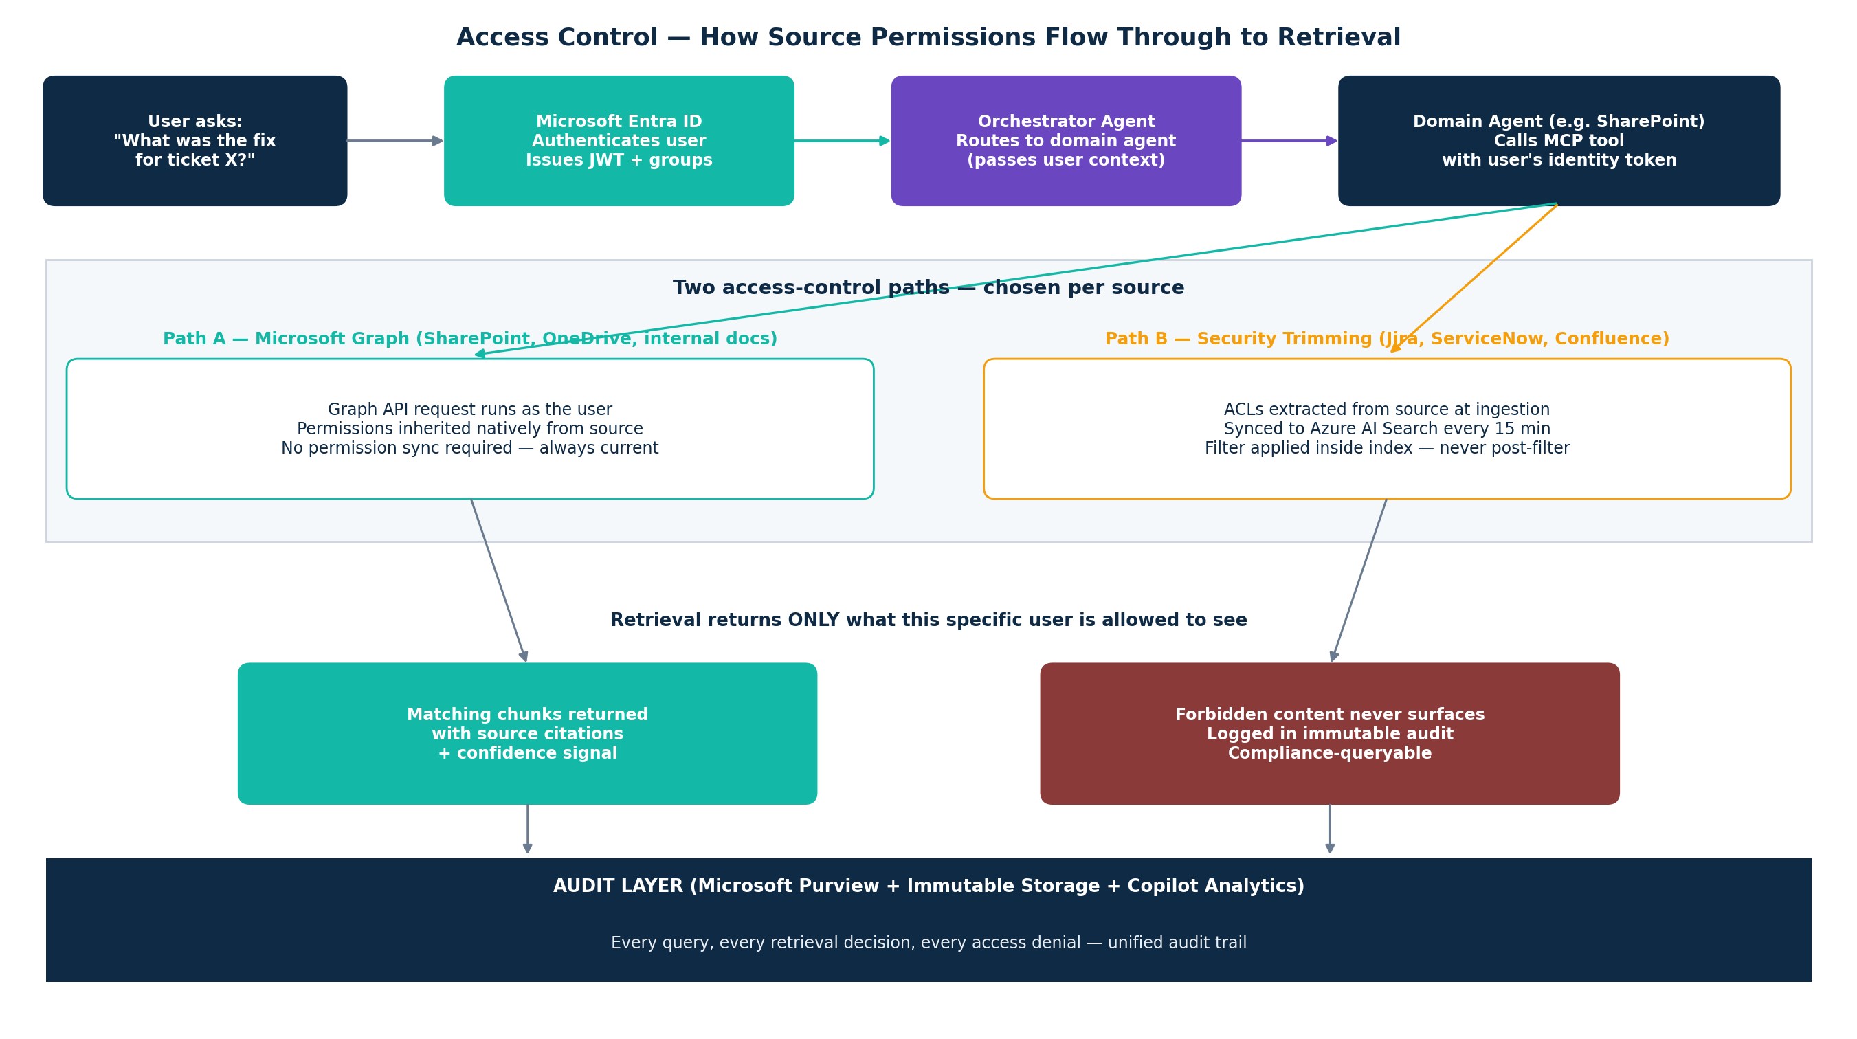
Figure 3 — Two complementary access-control paths: Microsoft Graph native inheritance for Graph-compatible sources, Security Trimming for others.

6.1 Path A — Microsoft Graph native inheritance
For SharePoint, OneDrive, and M365 internal documentation, the architecture uses Microsoft Graph connectors. Graph API calls execute in the context of the requesting user — which means SharePoint and OneDrive enforce their own permission rules on the response. No permission synchronization is required. If a user's access is revoked at 10:00 AM, their next query at 10:01 AM sees the revocation immediately.
This is the cleanest and safest access-control model available. It is the default choice for every source where it applies.

6.2 Path B — Security Trimming on Azure AI Search
Jira, ServiceNow, and Confluence are not Graph-native. For these sources, access control is enforced through Security Trimming on Azure AI Search. At ingestion, each indexed chunk carries its source ACL as metadata. At query time, the user's group claims are converted into a filter expression applied inside the search — forbidden chunks are never returned.
ACLs are synchronized to the index on two triggers: every 15 minutes on schedule (to catch drift), and event-driven on every source-system permission change (to react in near real time). If reconciliation detects that more than 5% of content would be removed in a single sync, the sync is paused and an alert is raised — this protects against source-API outages that would otherwise silently wipe access.

6.3 Why access control is enforced inside the index, never as a post-filter
A common anti-pattern is to retrieve all matching content, then filter out what the user cannot see. This is architecturally unsafe — any leak in the retrieval-to-response path (including prompt injection) can cause forbidden content to surface. The design choice here is deliberate: forbidden content never enters the retrieval response in the first place.

6.4 Handling highly confidential data
- Purview classification labels (Confidential, Highly Confidential, Restricted) are read at ingestion and stored as filterable metadata on every chunk.
- Attribute-based access policies (via Open Policy Agent as a Copilot Studio sidecar) resolve complex conditions — e.g., "user must be in group X AND document must not be classified as Restricted."
- Restricted-tier content retrieval optionally runs on Azure Confidential VMs (AMD SEV-SNP) — memory is encrypted and inaccessible to the hypervisor. Recommended for the highest-sensitivity tier if applicable.
- All access denials are logged to the immutable audit store — compliance can query "who was denied what content, when, and why" as a single SQL query.

7. Data Flow, Recency, and Accuracy
The agent-first architecture changes how recency is maintained. Because agents query their sources in real time via MCP tools, the concept of "freshness SLA" applies differently to Graph sources and index-backed sources.

7.1 Graph-connected sources — recency is automatic
SharePoint, OneDrive, and M365 documents are queried live through Graph. The content returned is always the current state. There is no index to refresh, no reconciliation to run, no staleness window to tolerate. The only freshness consideration is Graph connector content crawl cadence — configurable per source, typically set to 15 minutes for a pilot.

7.2 Index-backed sources — two-mode refresh
Jira, ServiceNow, and Confluence content lives in Azure AI Search. The index is refreshed through two complementary mechanisms:
- Event-driven — webhooks from Jira (issue create/update/delete/transition), ServiceNow Business Rules on incident/problem/change tables, and Confluence page webhooks fire immediately on source change, triggering Azure Functions that re-index the affected record.
- Scheduled reconciliation — every night, a reconciliation job fetches a full manifest of (doc_id, checksum, updated_at) from each source and compares it to the index. Drift is classified as NEW, UPDATED, MISSING, or STALE and remediated automatically. This catches webhook delivery failures and source-side backdating.

7.3 Accuracy signals surfaced to users
- Every response carries inline citations linked to the source chunk.
- Every retrieved chunk older than 90 days displays a freshness indicator in the UI — "verify before acting."
- Confidence signal (High / Medium / Low) is derived from groundedness score and retrieval coverage.
- When the orchestrator cannot produce a confidently-grounded answer, it returns the structured fallback — not a hallucinated response.

8. Pilot Scope — 8 Weeks
The pilot is deliberately focused. Its goals are to validate the architecture end-to-end on two sources, confirm the access-control model in production conditions, measure real user value, and produce a repeatable pattern for Phase 2 expansion.

8.1 In-scope for pilot
- Orchestrator Agent in Copilot Studio — full functionality.
- Confluence Agent + Confluence MCP server — real-time retrieval with Security Trimming.
- SharePoint Agent via Graph Connector — real-time retrieval with native ACL inheritance.
- User access: Microsoft Teams (primary surface), custom minimal web UI (for admins and power users).
- Governance: Entra ID identity, Purview classification ingestion, immutable audit log, Copilot Analytics dashboard.
- Evaluation: 50-question golden dataset, weekly RAGAS scoring, user feedback capture.
- Pilot user group: 50 to 100 users across 2 to 3 business functions.

8.2 Out of scope for pilot (Phase 2+)
- Jira Agent, ServiceNow Agent, Internal Docs Agent — templated and ready; deployment deferred to Phase 2.
- Custom web UI beyond minimal admin interface — pilot runs primarily in Teams.
- Multi-region deployment and DR — single region for pilot; DR posture designed for Phase 2 production.
- Advanced evaluation (LLM-as-judge across a full production-sampled set) — lightweight RAGAS only in pilot.

8.3 Eight-week plan
Week | Activities | Milestone
1 | Kickoff · Entra ID group model review · Purview classification review · golden-dataset curation workshop with SMEs | Platform access approvals signed · Copilot Studio environment provisioned
2 | SharePoint Graph Connector configured · ACL test suite drafted · orchestrator agent skeleton in Copilot Studio | SharePoint content crawlable and ACL-verified
3 | Confluence MCP server built (containerized on Azure Container Apps) · ACL extraction pipeline · Azure AI Search index provisioned | Confluence MCP server handling test queries end-to-end
4 | SharePoint Agent wired to orchestrator · cross-source routing logic · citation rendering in Teams adaptive cards | SharePoint queries answered in Teams with citations — internal demo
5 | Confluence Agent wired · Security Trimming validated with ACL test suite · groundedness evaluation harness deployed | Both domain agents operational — access control validated
6 | Pilot user group onboarded (50-100 users) · Copilot Analytics dashboard live · user feedback capture deployed | Pilot live with real users
7 | Active monitoring · feedback triage · agent prompt tuning based on production traffic · freshness signals tuned | Measurable usage data · first RAGAS regression cycle
8 | Pre/post measurement finalized · Phase 2 expansion plan · handover documentation · Board-ready success report | Pilot sign-off · Phase 2 green-light decision

9. Governance, Monitoring and Audit
The Client requires centralized monitoring and auditing for unified tracking of usage, access patterns, and compliance. The architecture satisfies this through four integrated surfaces — all existing components in the Client's tenant.
Surface | What it captures | Primary users
Microsoft Purview | Data classification · lineage · retention · sensitive-data scanning | Compliance · Data Protection Officer
Entra ID access logs | Every authentication · every permission grant · every access decision | Security Operations · Identity team
Copilot Analytics | Agent usage · query patterns · response quality · user satisfaction | Product owner · KM Lead
Immutable audit store (Blob + WORM + legal hold) | Every retrieval · every source chunk returned · every decision including denials | Audit · Compliance · Regulatory review

9.1 The unified audit query
The four surfaces above feed a unified audit model. A compliance officer can answer questions like "which users queried confidential content related to Project X in the last 90 days" as a single query across the audit store — the answer is always complete, always time-stamped, and always immutable.

9.2 Continuous improvement loop
- Weekly RAGAS regression run against the golden dataset — fails auto-block the next prompt or agent change.
- User feedback (thumbs, corrections) is triaged by SMEs before entering the evaluation set — prevents feedback-loop poisoning.
- Monthly "Knowledge Health" review embedded in the existing Client tech huddle — no new meetings.

10. Pilot Success Metrics
Every commitment in this pilot is measurable. Baselines are established in Week 1 using Copilot Analytics (if in use), survey data, and stopwatch testing. Targets are set against baseline, not industry benchmarks, so the Board sees a real, defensible delta at Week 8.
KPI | Definition | Target (Week 8)
Answer groundedness | % of responses with all claims traceable to a source chunk | ≥ 95%
Citation accuracy | % of citations that actually support the claim (sampled) | ≥ 90%
Access-control correctness | Test-suite pass rate (zero tolerance for false positives) | 100%
Time-to-answer | Avg user time from question to usable answer | ↓ 50% vs baseline
Weekly active users | % of pilot cohort using at least once per week | ≥ 70%
User satisfaction | Score on "I trust the answers I get" (1–5) | ≥ 4.0 / 5
Deflection rate | % of queries fully answered without SME escalation | ≥ 60%

11. Team and Commercial Shape

11.1 delivery team
Role | Allocation | Responsibility
Engagement Lead / Architect (Nisarg) | 1.0 FTE across 8 weeks | End-to-end technical ownership · agent design · client-facing delivery · Phase 2 roadmap
Senior Platform Engineer | 1.0 FTE across 8 weeks | MCP servers · Azure Container Apps · Azure AI Search · CI/CD
Senior AI Engineer | 1.0 FTE Weeks 2–8 | Copilot Studio agent authoring · prompt design · evaluation harness · RAGAS integration
Security Engineer | 0.5 FTE across 8 weeks | Entra ID · Graph permissions · Security Trimming · audit design · access-control test suite
Change Manager | 0.3 FTE Weeks 5–8 | Pilot user onboarding · adoption · feedback capture · handover

Total effort: approximately 3.4 FTE-equivalent over eight weeks (roughly 27 person-weeks).

11.2 Commercial structure
- Fixed-fee, milestone-billed: 25% at kickoff · 25% at Week 4 (agents operational) · 25% at Week 6 (pilot live) · 25% at Week 8 (handover signed).
- Detailed fee confirmed in a separate commercial document.
- Phase 2 expansion scoped and priced separately on pilot success.

12. Risks and Mitigations
Risk | Mitigation
SharePoint permissions are inconsistent across legacy sites | Week 1 permissions audit identifies outliers; pilot scope excludes sites with broken permission inheritance until remediated by Client site owners
MCP server for Confluence hits Atlassian rate limits under load | Per-source token-bucket rate limiting · exponential backoff · circuit breaker at 10% error rate over 5 min · response caching for repeat queries
Pilot users experience slow responses (cold agent start) | Pre-warmed Copilot Studio agents · Azure Container Apps min-replicas set for MCP servers during pilot hours · streaming responses in Teams
Prompt injection via malicious Confluence content | Azure AI Content Safety pre- and post-generation · retrieval-time suspicious-pattern filter · strict citation prompt that strips uncited claims
Feedback loop data poisoning | SME triage before eval-set admission · anomaly detection on correction patterns · human-in-the-loop mandatory before regression dataset changes
Azure OpenAI capacity throttling | Request capacity pre-allocated before Week 6 pilot launch · fallback routing to secondary Azure OpenAI regional deployment · model routing (GPT-4o-mini for classification, GPT-4o for synthesis)
MCP protocol still evolving | Implementations pinned to stable protocol version · connector interfaces abstracted so protocol revision is isolated to the connector layer
Scope creep mid-pilot | Fixed scope documented in §8; additional sources scoped and priced as Phase 2 work; no absorption into pilot timeline

13. Phase 2 Expansion
On successful pilot completion, the architecture expands to the remaining three sources (Jira, ServiceNow, Internal Docs) through the same MCP pattern. This is the value of the architectural choice — Phase 2 is onboarding, not engineering.

13.1 Expansion cadence
Source | Duration | Key work
Jira | 2–3 weeks | Custom MCP server (REST v3) · ACL extraction · Azure AI Search index namespace · Security Trimming validation
ServiceNow | 2–3 weeks | Custom MCP server (Table API) · role-based ACL extraction · incident / problem / KB table ingestion · ACL validation
Internal Docs (M365) | 1–2 weeks | Graph Connector configuration · Purview classification mapping · native ACL inheritance — minimal custom code
Multi-region + DR | 2–3 weeks | Secondary region deployment · traffic manager · async replication of Azure AI Search index · DR runbook

Total Phase 2 duration: approximately 8–10 weeks of additional engineering. All three remaining agents can be developed in parallel because the orchestrator is already in place.

14. Next Action
To start Week 1 of the pilot within two weeks of sign-off:
- Engagement sign-off and commercial structure confirmed.
- Executive sponsor nominated (suggested: Head of Engineering or CTO delegate).
- Pilot user cohort of 50–100 identified (suggested: 2–3 functions with highest SME-escalation volumes).
- Read-only access approvals initiated for Confluence and SharePoint pilot content.
- Copilot Studio environment and Azure resource group allocated by Client platform team.
- Entra ID groups for pilot cohort confirmed.

15. Phase 2 Scope — 10 Weeks
15.1 In-scope for Phase 2
- Orchestrator Agent Upgrades: Hierarchical semantic routing across all 5 domain agents.
- Jira Agent + Jira MCP server: Real-time retrieval with project and issue-level Security Trimming.
- ServiceNow Agent + ServiceNow MCP server: Real-time retrieval with role-based access filtering.
- Internal Docs Agent via Graph Connector: Expanded footprint for network-isolated M365 documentation shares.
- Infrastructure Hardening: Active-passive multi-region deployment and automated failover routing.
- Evaluation: Production-sampled "LLM-as-a-judge" continuous test harness over an expanded 300+ question golden dataset.
- User access: Full organization-wide deployment across Microsoft Teams and desktop surfaces.

15.2 Ten week plan
Week | Activities | Milestone
1 | Production hardening · Infrastructure mirroring across secondary Azure region · Automated CI/CD pipelines via GitHub Actions | HA/DR infrastructure active; automated deployment verified
3–4 | Jira & ServiceNow MCP servers containerized on Azure Container Apps · Webhook handlers configured · ACL-to-SID extraction pipelines live | New MCP servers handling test queries with strict Security Trimming
5–6 | Extended M365 Graph Connectors configured · Orchestrator upgraded to 5-agent semantic routing · Automated RAGAS evaluation harness deployed | All 5 domain agents operational under unified orchestration
7–8 | Automated load testing via Azure Chaos Studio · Penetration testing & prompt injection simulation · 15-minute scheduled ACL reconciliation stress-tested | Security audit signed off; infrastructure capacity auto-scaling tuned
9–10 | Phased global rollout (1,000 power users wave $\rightarrow$ wide access) · Purview lineage dashboard live · Support runbook handover to operations | Final platform sign-off; operations team assumes production ownership

16. Governance, Monitoring and Audit
- Telemetry Surfaces: Reuses the four baseline surfaces validated in the Pilot (Microsoft Purview, Entra ID, Copilot Analytics, and Immutable Audit Store).
- Phase 2 Delta: Scale logging pipelines to capture cross-region Traffic Manager telemetry and custom trace metrics for the new Jira and ServiceNow MCP servers.

16.1 The unified audit query
- Unchanged from Pilot: Retains the single-query audit model across the consolidated WORM store, now natively extending queries to cover Jira project permissions and ServiceNow incident security logs.

16.2 Continuous improvement loop
- Weekly automated regression runs scale from the 50-question pilot set to the expanded 300+ question enterprise golden dataset.
- Negative user feedback (thumbs-down/text corrections) automatically populates an SME triage queue before entering the evaluation set.

17. Phase 2 Success Metrics
Production milestones are evaluated against baseline system metrics gathered at the end of the Phase 1 pilot to demonstrate measurable enterprise-grade stability.
KPI | Definition | Target (Phase 2 State)
System Availability | Platform uptime SLA maintained via Azure Traffic Manager | ≥99.9%
Access-control correctness | Test-suite pass rate (Zero tolerance for data leakage) | 100%
Answer groundedness | % of responses with all claims traceable to source system chunks | ≥98%
Citation accuracy | % of citations that explicitly support the generated claim | ≥95%
Time-to-answer | End-to-end latency for complex, cross-source multi-agent synthesis | ≤3.5 seconds
Deflection rate | % of routine queries fully answered without human SME escalation | ≥65%

18. Team and Commercial Shape

18.1 Delivery team
The core pod scales from 3.4 FTE to 5.5 FTE to support parallel source ingestion streams:
- Engagement Lead / Principal Architect (Nisarg) [1.0 FTE]: Unchanged from Pilot.
- Senior Platform Engineer [1.0 FTE]: Dedicated to CI/CD pipelines, HA/DR infrastructure provisioning, and multi-region index management.
- Senior AI Engineer [2.0 FTE]: Scaled up to handle simultaneous containerization of Jira and ServiceNow MCP servers.
- Security & Identity Engineer [1.0 FTE]: Dedicated to token propagation verification and deep Purview mapping across the new data sources.
- Enterprise Change Manager [0.5 FTE]: Managing enterprise-wide communication, adoption waves, and support desk training.

18.2 Commercial structure
- Fixed-fee, milestone-billed: 25% at Phase 2 kickoff · 25% at Week 4 (Jira & ServiceNow operational) · 25% at Week 6 (5-agent system integrated) · 25% at Week 10 (Production handover signed).
- Detailed fee confirmed in a separate commercial document.

19. Risks and Mitigations
Risk | Mitigation
Jira/ServiceNow API rate limiting under enterprise load | Per-source token-bucket throttling implemented in custom MCP servers · Regional Redis cache cluster layers for frequent queries
Privilege escalation via malicious source content injection | Pre-query metadata injection: Entra ID security tokens are appended to search queries at the system layer—the LLM prompt never controls the filter
Increased routing latency across 5 distinct domain agents | Parallelized MCP tool execution calls · Intent classification routing offloaded to optimized gpt-4o-mini models, leaving gpt-4o strictly for final synthesis
Data drift from missed webhooks in index-backed sources | Nightly reconciliation jobs compare index manifests against live source checksums to detect and patch NEW, UPDATED, or STALE items automatically

20. Next Actions
To launch Week 1 of Phase 2 within two weeks of pilot sign-off:
- Phase 2 engagement sign-off and commercial structure confirmed.
- Read-only production API credentials and network firewall whitelisting initiated for Jira Cloud and ServiceNow instances.
- Rollout wave schedule mapped for the initial enterprise business units.
- Production Azure OpenAI capacity limits pre-allocated within the primary and secondary regions to ensure uninterrupted model availability.

